Difference Equations and Z-Transforms

Alpha-Beta Tracker

Team: Carpe Noctem

Team Leader: Jake Tisdale

Team Members: Carlos Lazo, Christopher Rappa, Jake Tisdale, Mike Sangillo

Course: TDC1

Instructor: Karl Brommer

Group Hours: 25 hours

Date Submitted: 11/24/2008

Executive Summary

Problem
A government customer is asking our group, Carpe Noctem, to communicate with a satellite that orbits the Earth once every two hours. The satellite transmits data to a ground station as it passes overhead. Due to high velocity as it comes over the western horizon, the satellite has only 25 minutes to transmit data before it falls out of sight over the eastern horizon. As the satellite passes over the ground station, the velocity is constantly changing due to its orbital path. The received data has a frequency shift due to the Doppler Effect. To compensate for the frequency shift, a Phase Lock Loop (PLL) is used. This PLL needs to correct the shift and adjust its parameters over the 25-minute window. Carpe Noctem will analyze a single portion of the PLL known as the alpha-beta tracker.
This document shall analyze the characteristics of the alpha-beta tracker and shall state recommendations for the start-up and steady state operating conditions.

Method of Analysis
Our approach is as follows.

- Determine the transfer functions of the alpha-beta tracker between the output/error and input signals.
- Characterize the effects that α and β variables have on the poles of the tracker system.
- Determine the boundaries/regions that the poles create in terms of:
  - Stable and critically damped
  - Stable and under-damped
  - Stable and over-damped
  - Unstable
- Characterize the frequency response/bandwidth of the tracker with respect to α and β.
- Recommend start-up and steady state α and β ranges for the 25-minute communication window.

Results / Recommendations
- Carpe Noctem recommends operating the alpha-beta tracker within stable limits. This is done by setting the gains such that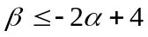.

- We recommend that the given start-up gains of α = 1 and β = 1 be kept. These gains have the response necessary to ensure optimal performance with an unknown original Doppler shift by creating an all pass frequency response.

- As the system reaches steady state, we recommend tuning the value of β, by gradually decreasing its value to bring the low-pass notch frequency closer to zero.

Table of Contents
Executive Summary 2
Problem 2
Method of Analysis 2
Results / Recommendations 2
Problem Statement 4
Overview 4
System Description 4
Assumptions 5
System Analysis 6
Approach 6
Detailed Analysis 6
Results 10
Results 10
Recommendations 11
References 12
Appendix 13

List of Figures

Figure 1: Phase Lock Loop Receiver 4
Figure 2: Alpha-Beta Tracker 5
Figure 3: System Stability and Dampening Regions 7
Figure 4: Frequency Response for α = 1 and 0.1 and β = 1 8
Figure 5: Frequency Response for Changing α and β = 1 8
Figure 6: Frequency Response for α = 0.1 and Changing β 9

Nomenclature
Symbol | Definition | Units
α | Path 1 proportional gain (Refer to Mason’s Rule: Appendix) | N/A
β | Path 2 proportional gain (Refer to Mason’s Rule: Appendix) | N/A
H(z) | The transfer function of x to y | N/A
x(nT) | Alpha-Beta tracker input (Refer to Figure 2) | N/A
y(nT) | Alpha-Beta tracker output (Refer to Figure 2) | N/A
e(nT) | Alpha-Beta tracker error signal(Refer to Figure 2) | N/A

Problem Statement

Overview

A government customer is asking our group, Carpe Noctem, to communicate with a satellite that orbits the Earth once every two hours. The satellite transmits data to a ground station as it passes overhead. Due to high velocity as it comes over the western horizon, the satellite has only 25 minutes to transmit data before it falls out of sight over the eastern horizon. As the satellite passes over the ground station, the velocity is constantly changing due to its orbital path. The received data has a frequency shift due to the Doppler Effect. To compensate for the frequency shift, a Phase Lock Loop (PLL) is used. This PLL needs to correct the shift and adjust its parameters over the 25-minute window. Carpe Noctem will analyze a single portion of the PLL known as the alpha-beta tracker.

System Description

A receiver uses a Phase Lock Loop (PLL) to correct the phase shift associated with the Doppler effect. The process uses a Voltage Controlled Oscillator (VCO) as a local oscillator and compares its output to the incoming signal to obtain a phase error and a demodulated signal as shown in Figure 1. The input to the VCO is the output of the alpha-beta tracker.

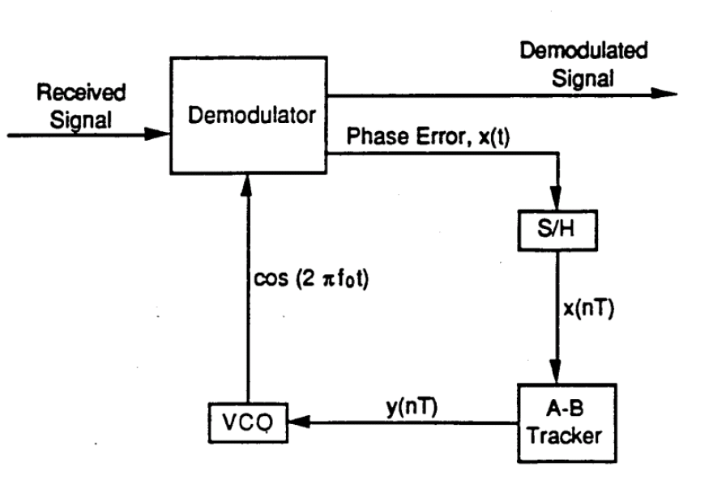
Figure 1: Phase Lock Loop Receiver

The purpose of the alpha-beta tracker is to sample the phase error between the local-oscillator and the received signal to produce a smoothed estimate of the current phase shift. The alpha-beta tracker receives the phase error x(nT) and outputs a signal y(nT) that commands the local oscillator to adjust its frequency accordingly. The ultimate goal of the alpha-beta tracker is to minimize the phase error between the received signal and local oscillator signal. The system achives this goal through the tuning of the gains α and β. Figure 2 shows Carpe Noctem’s block diagram of the alpha-beta tracker.

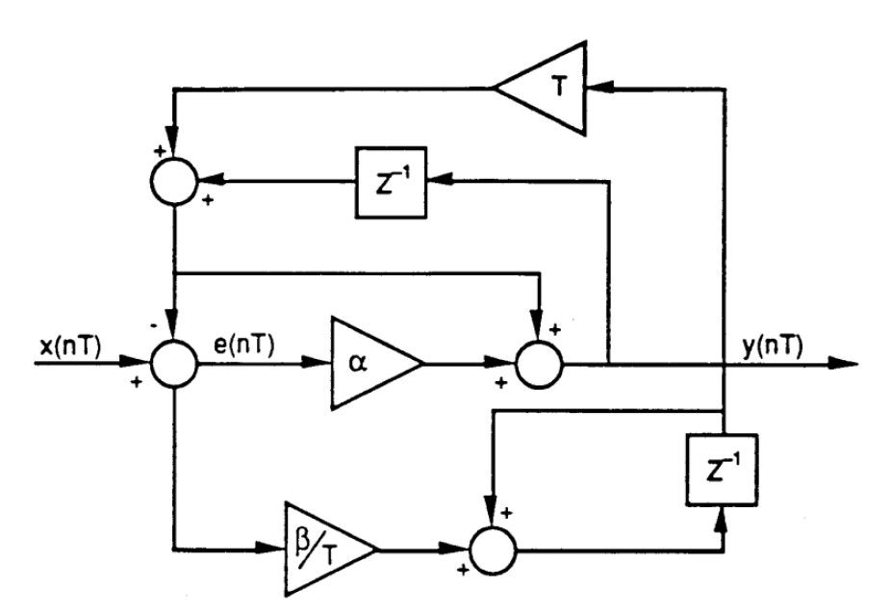
Figure 2: Alpha-Beta Tracker

Assumptions

- Carpe Noctem assumes that the gains of the alpha-beta tracker are adjustable.
- If not, our team cannot adjust the response of the system and the analysis is not possible.

- We assume that the sampling frequency is above the Nyquist frequency for the system.
- Aliasing effects are not in the scope of this report.

System Analysis

Approach

- Find the transfer function from the tracker input to the smoothed estimate of the current phase shift (H(z)) and the transfer function from the tracker input to the error signal (H_{e}(z)).
- Determine the order of the alpha-beta tracker.
- Examine the poles of the transfer function.
- Find ranges for α and β where the impulse response is unstable, stable and under- damped, and stable and over-damped.
- Examine the frequency response for the transfer function for different values of α and β.
- Examine the start-up operating conditions for the system.
- Examine the steady-state operating conditions for the system.

Detailed Analysis

We derive the total transfer H(z) function using Mason’s rule; this process is shown in the appendix. Equation 1 shows the transfer function for the alpha-beta tracker output. This is a second order system because the highest power in the denominator is two.

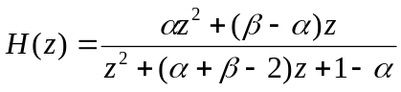 Equation 1

Again, we use Mason’s rule to find H_{e}(z). We have also shown this derivation in the appendix. Equation 2 shows the transfer function for the error signal.

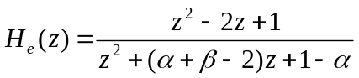 Equation 2

We next need to look at H(z) to find the ranges of α and β that yield unstable and stable results. For the stable responses, we also need to find the ranges of α and β that yield over-damped or under-damped impulse responses.

A system is unstable if none of its poles lay on the complex unit disk. This occurs when the magnitude of any pole is greater than one. The roots of the transfer function’s denominator show the poles of the system. This is our pole equation p(z) (Equation 3).

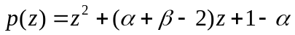 Equation 3

Now we need to find our poles. For this, we use the quadratic equation (Equation 4).

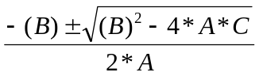 Equation 4
For our application, the coefficients used in the quadratic formula are A = 1, B = 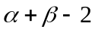 and C =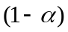. To find the border region of instability, we set the magnitude of quadratic equation equal to one (Equation 5) and solve for β (Equation 6). This will give us the line of α and β values where the response is marginally stable. Below this line, the system is stable, while the converse is unstable.

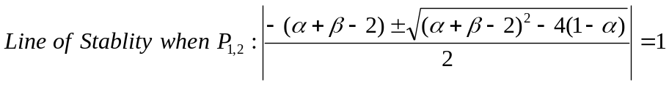 Equation 5

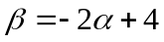 Equation 6

Now that we have found the regions of stability and instability, we need to examine the dampening of the impulse response. We do this by examining the radical of the quadratic equation. If the radical (Equation 7) is real, the system is over-damped. If the radical is complex, the system is under-damped. If the radical is zero the system is critically damped.

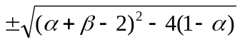 Equation 7

To find the regions of under and over damping, our group plots the line of critical dampening. We do this by setting Equation 7 to zero and solving for β (Equation 8).

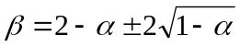 Equation 8

We graphed these regions using MATLAB with α as the abscissa and β as the ordinate as seen in Figure 3.

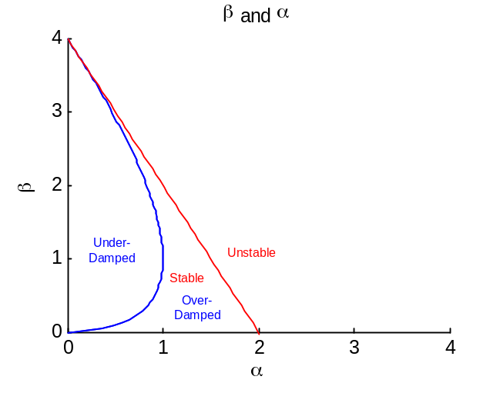
Figure 3: System Stability and Dampening Regions
We now want to examine the frequency response of the alpha-beta tracking system. We do this by substituting 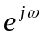 for z in the transfer function as seen in Equation 9.
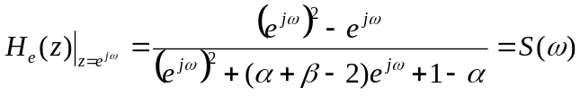 Equation 9

We then plot the frequency responses using different values for α and β via MATLAB.

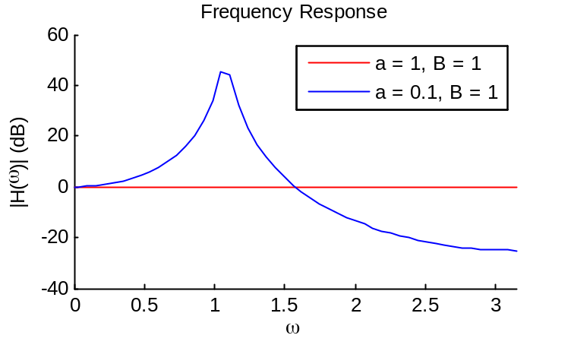
Figure 4: Frequency Response for α = 1 and 0.1 and β = 1
The start up conditions for our system are α = 1 and β = 1. In the start up mode, we are unsure of the Doppler Effect on the incoming signal and need our system to be an all-pass filter to accept all frequencies for correction. The red line in Figure 4 shows the frequency response for our start-up conditions. These conditions produce an all-pass filter. Therefore, the gains α = 1 and β = 1 are satisfactory for use during start up.
For the blue line in Figure 4, α = 0.1 and β = 1, these are the settings for the steady-state operation of the system. In order for this to be effective at steady state, the system must be stable. The magnitude of our poles is 0.9487; since this is less than one, our poles fall within the unit disk and the system is stable.
To explain the response in more detail, we examine the effect of changing the gains of the frequency response of our system. In Figure 5, we have shown the effect of changing α but keeping β = 1. In this graph, we can see that the value of α adjusts the gain of the system in notch region. As we decrease α, the gain is increased.

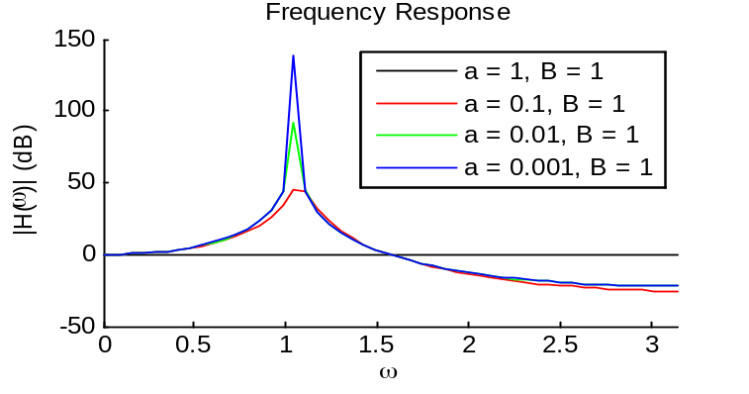
Figure 5: Frequency Response for Changing α and β = 1
In Figure 6, we have shown the effect of changing β but keeping α = 0.1.

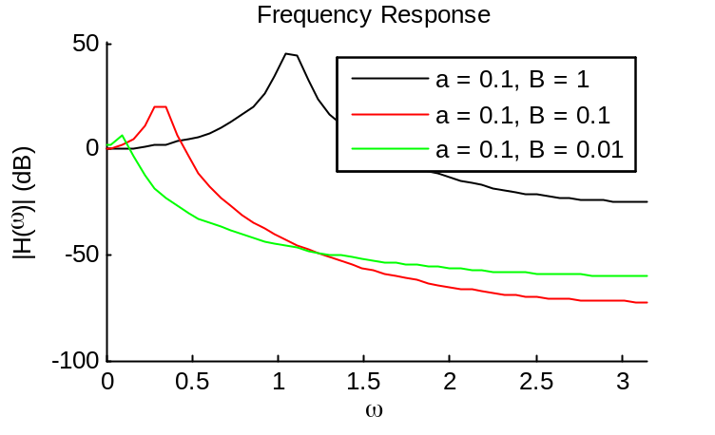
Figure 6: Frequency Response for α = 0.1 and Changing β
In this graph, we can see that the value of β adjusts the position of the notch region. As we decrease β, the notch frequency decreases. This is helpful in steady state because the error is very small. At steady state, our system will consist primarily of a slow changing signal with superimposed high frequency noise. We would like our system to operate as a low pass filter. In other words, we want the lower frequency content amplified and the high frequency noise attenuated. If we set α = 0.1, we can get this performance with the ability to tune our response by only varying β.

Results

Results

Number | Pertinent Result
1. Transfer functions | 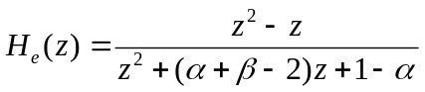
2. Gains for which the tracker is unstable, stable and over-damped, and stable and under-damped | Please see Figure 3: System Stability and Dampening Regions.
3. Order of alpha-beta tracker | 2
4. Start up region – gains and their adjustment | In the start up mode, we are unsure of the Doppler affect on the incoming signal and need our system to be an all-pass filter to accept all frequencies for correction. The red line in Figure 4 shows the frequency response for our start-up conditions. These conditions produce an all-pass filter. Therefore, the gains α = 1 and β = 1 are satisfactory for use during start up.  In Figure 5, we can see that the value of α adjusts the gain of the system in notch region. As we decrease α, the gain is increased.  In Figure 6, we can see that the value of β adjusts the position of the notch region. As we decrease β, the notch frequency decreases.
5. Magnitude response and steady state operation | Please see Figure 4: Frequency Response for α = 1 and 0.1 and β = 1, specifically, the blue line.  The magnitude of our poles is 0.9487; since this is less than one, our poles fall within the unit disk and the system is stable.  We would like our system to operate as a low pass filter. If we set α = 0.1, we can get this functionality with the ability to tune our response by varying β.

Recommendations

Team Carpe Noctem recommends that the alpha-beta tracker be operated within stable limits. This is done by setting the gains such that.

Through our analysis, we suggest that the given start-up gains of α = 1 and β = 1 be kept. These gains have the response necessary to ensure optimal performance with an unknown original Doppler shift by creating an all pass frequency response.

As the system reaches steady state, we recommend tuning the value of β, by gradually decreasing its value to bring the low-pass notch frequency closer to zero.

References

Kamen, Edward, and Bonnie Heck. Fundamentals of Signals and Systems Using MATLAB. Prentice Hall, 2000.

Appendix

MATLAB Code

%% Week 12: Z-Transforms
% Coded by Christopher C. Rappa
% November 18, 2008
syms a B damp stable p1
t = linspace(0,4,100);
damp = solve('(a + B - 2)^2 - 4*(1 - a) = 0',a);

y1 = subs(damp(1),B,t);
y2 = subs(damp(1),B,t);

figure; hold on;
plot(y1,t);
plot(y2,t);
plot(t,-2*t+4,'r');
hold off;
xlim([0 4]); ylim([0 4]);
title('\beta and \alpha');
xlabel('\alpha');
ylabel('\beta')

%%
% stable2 = solve('abs((-(a+B-2)-sqrt((a+B-2)^2-4*(1-a)))/2) = 1','B');
% stable = solve('abs((-(a+B-2)+sqrt((a+B-2)^2-4*(1-a)))/2) = 1','B');
%
% %%
% clear all;
% N = 100;
% a = linspace(0,10,N);
% B = a;
%
% f = inline('(-(a+B-2)-sqrt((a+B-2)^2-4*(1-a)))/2','a','B');
%
% for i = 1:N
% for j = 1:N
% result(i,j) = abs(f(a(i),B(j))); %#ok<AGROW>
% end
% end
% mesh(a,B,result);

%%
clear all;
figure;
H = inline('(a*z.^2 + (B - a)*z) ./ (z.^2 + (a + B -2)*z + 1 - a)','a','B','z');
w = linspace(-pi,pi,100);
z = exp(i*w);

hold on;
a = 1; B = 1;
Y = H(a,B,z);
plot(w,20*log(abs(Y)),'r')

a = 0.1; B = 1;
Y = H(a,B,z);
plot(w,20*log(abs(Y)))
hold off;

xlim([0 pi]);
title('Frequency Response');
ylabel('|H(\omega)| (dB)');
xlabel('\omega');
legend('a = 1, B = 1','a = 0.1, B = 1')

%%
clear all; figure; hold on;
H = inline('(a*z.^2 + (B - a)*z) ./ (z.^2 + (a + B -2)*z + 1 - a)','a','B','z');
w = linspace(-pi,pi,100);
z = exp(i*w);

a = 0.1; B = 1;
Y1 = H(a,B,z);
a = 0.1; B = 0.1;
Y2 = H(a,B,z);
a = 0.1; B = 0.01;
Y3 = H(a,B,z);

plot(w,20*log(abs(Y1)),'k')
plot(w,20*log(abs(Y2)),'r')
plot(w,20*log(abs(Y3)),'g')
hold off;
xlim([0 pi]);
title('Frequency Response');
ylabel('|H(\omega)| (dB)');
xlabel('\omega');
legend('a = 0.1, B = 1','a = 0.1, B = 0.1','a = 0.1, B = 0.01')

%%
clear all; figure; hold on;
H = inline('(a*z.^2 + (B - a)*z) ./ (z.^2 + (a + B -2)*z + 1 - a)','a','B','z');
w = linspace(-pi,pi,100);
z = exp(i*w);

a = 1; B = 1;
Y1 = H(a,B,z);
a = 0.1; B = 1;
Y2 = H(a,B,z);
a = 0.01; B = 1;
Y3 = H(a,B,z);
a = 0.001; B = 1;
Y4 = H(a,B,z);

plot(w,20*log(abs(Y1)),'k')
plot(w,20*log(abs(Y2)),'r')
plot(w,20*log(abs(Y3)),'g')
plot(w,20*log(abs(Y4)))
hold off;
xlim([0 pi]);
title('Frequency Response');
ylabel('|H(\omega)| (dB)');
xlabel('\omega');
legend('a = 1, B = 1','a = 0.1, B = 1','a = 0.01, B = 1','a = 0.001, B = 1') %CR

Mason’s Rule for H(z):

The four loops depicted in this diagram are

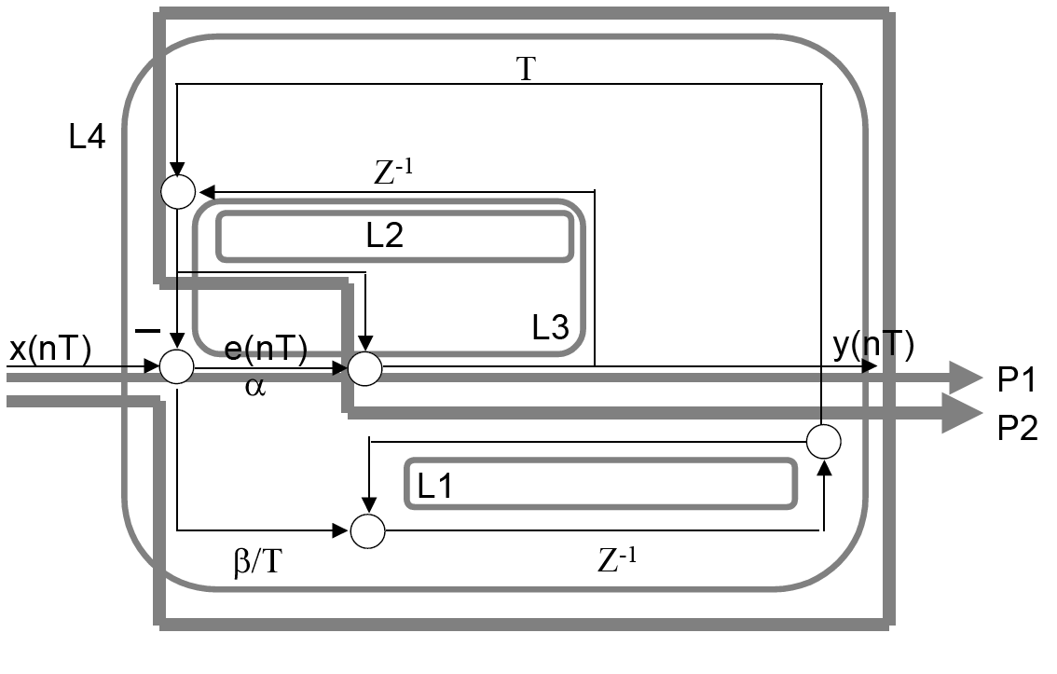
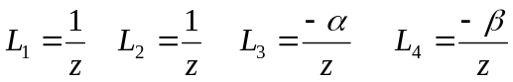

Only the loop pairs (L1, L2), and (L1, L3) do not intersect:

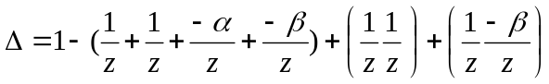
The two direct paths are:
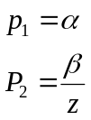
The Respective cofactors are found by zeroing the transmittances along all loops intersecting the paths in question:
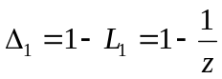
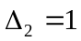
The total transmittance from x1 to x2 is:
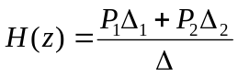
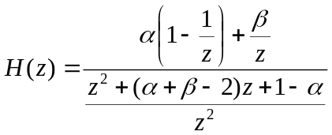
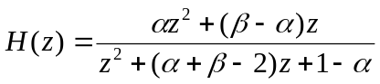

Derivation of transfer function for the error signal (e(nT)).

